**ASSIGNMENT – 5**

**Aim:** Design conceptual model using Star and Snowflake schema for any one database.

**Theory:**

**Star and Snowflake Schema in Data Warehouse with Model**

## **What is Multidimensional schema?**

**Multidimensional Schema** is especially designed to model data warehouse systems. The schemas are designed to address the unique needs of very large databases designed for the analytical purpose (OLAP).

Types of Data Warehouse Schema:

Following are 3 major types of multidimensional schemas each having its unique advantages.

* Star Schema
* Snowflake Schema
* Galaxy Schema

## **What is a Star Schema?**

**Star Schema** in data warehouse, in which the center of the star can have one fact table and a number of associated dimension tables. It is known as star schema as its structure resembles a star. The Star Schema data model is the simplest type of Data Warehouse schema. It is also known as Star Join Schema and is optimized for querying large data sets.

In the following Star Schema example, the fact table is at the center which contains keys to every dimension table like Dealer_ID, Model ID, Date_ID, Product_ID, Branch_ID & other attributes like Units sold and revenue.

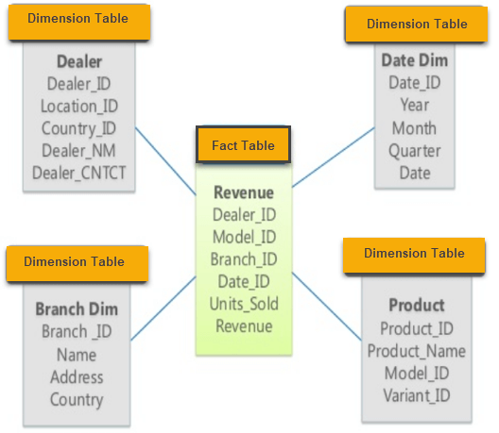

Example of Star Schema Diagram

### **Characteristics of Star Schema:**

* Every dimension in a star schema is represented with the only one-dimension table.
* The dimension table should contain the set of attributes.
* The dimension table is joined to the fact table using a foreign key
* The dimension table are not joined to each other
* Fact table would contain key and measure
* The Star schema is easy to understand and provides optimal disk usage.
* The dimension tables are not normalized. For instance, in the above figure, Country_ID does not have Country lookup table as an OLTP design would have.
* The schema is widely supported by BI Tools

## **What is a Snowflake Schema?**

**Snowflake Schema** in data warehouse is a logical arrangement of tables in a multidimensional database such that the ER diagram resembles a snowflake shape. A Snowflake Schema is an extension of a Star Schema, and it adds additional dimensions. The dimension tables are normalized which splits data into additional tables.

In the following Snowflake Schema example, Country is further normalized into an individual table.

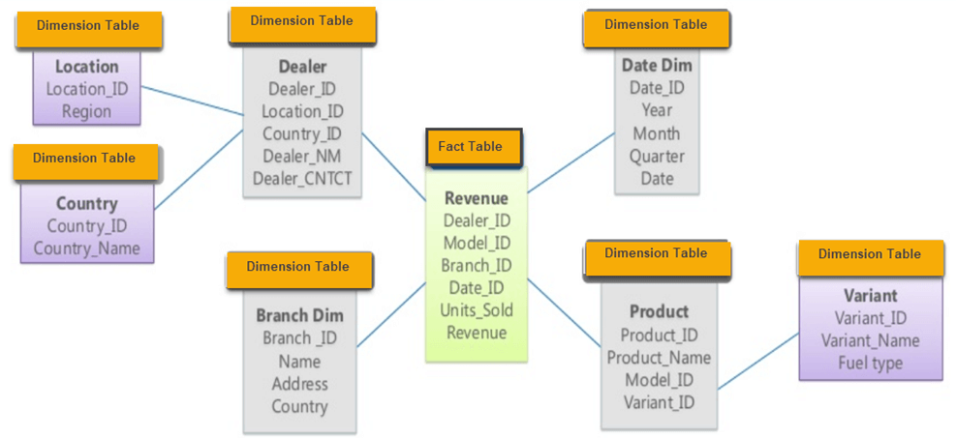Example of Snowflake Schema

### **Characteristics of Snowflake Schema:**

* The main benefit of the snowflake schema it uses smaller disk space.
* Easier to implement a dimension is added to the Schema
* Due to multiple tables query performance is reduced
* The primary challenge that you will face while using the snowflake Schema is that you need to perform more maintenance efforts because of the more lookup tables.

## **Star Schema Vs Snowflake Schema: Key Differences**

Following is a key difference between Snowflake schema vs Star schema:

|  |  |
| --- | --- |
| **Star Schema** | **Snowflake Schema** |
| Hierarchies for the dimensions are stored in the dimensional table. | Hierarchies are divided into separate tables. |
| It contains a fact table surrounded by dimension tables. | One fact table surrounded by dimension table which are in turn surrounded by dimension table |
| In a star schema, only single join creates the relationship between the fact table and any dimension tables. | A snowflake schema requires many joins to fetch the data. |
| Simple DB Design. | Very Complex DB Design. |
| Denormalized Data structure and query also run faster. | Normalized Data Structure. |
| High level of Data redundancy | Very low-level data redundancy |
| Single Dimension table contains aggregated data. | Data Split into different Dimension Tables. |
| Cube processing is faster. | Cube processing might be slow because of the complex join. |
| Offers higher performing queries using Star Join Query Optimization. Tables may be connected with multiple dimensions. | The Snowflake schema is represented by centralized fact table which unlikely connected with multiple dimensions. |

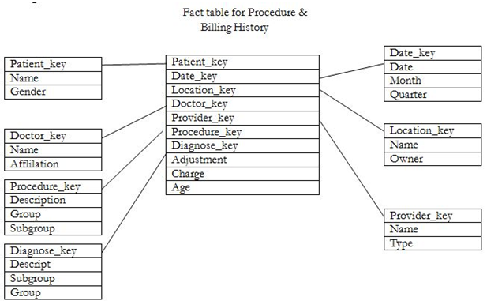

**Conclusion:** Thus we have studied the conceptual design using snowflake and star schema for an enterprise.